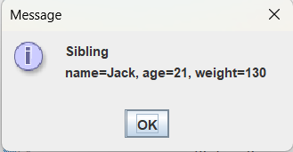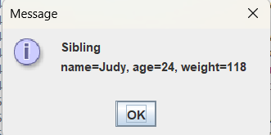

package as09;

//File: Sibling.java
import javax.swing.JOptionPane;

public class Sibling implements Status
{
private String name;
private int age;
private int weight;

public Sibling(String n, int a, int w)
{
name = n;
age = a;
weight = w;
}

public String getName()
{
return name;
}

public int getAge()
{
return age;
}

public int getWeight()
{
return weight;
}

public String getStatus()
{
String status = "Sibling\nname=" + name + ", age=" + age + ", weight=" + weight + "\n\n";
return status;
}

public void displayStatus()
{
String status = getStatus();
JOptionPane.showMessageDialog(null, status);
}
}

